

Draw it or Lose it

# **CS 230 Project Software Design Template**

Version 1.2

## Table of Contents

**CS 230 Project Software Design Template**1

**Table of Contents**2

**Document Revision History**2

**Executive Summary**3

**Design Constraints**3

**System Architecture View**3

**Domain Model**3

**Evaluation**3

**Recommendations**5

## Document Revision History

| Version | Date | Author | Comments |
| --- | --- | --- | --- |
| 1.0 | <05/16/2020> | Zachery Richardson | Added initial details about Draw it or Lose it. |

|  |  |  |  |
| --- | --- | --- | --- |
| 1.1 | <05/24/2020> | Zachery Richardson | Added details to the development requirements for the multiple types of Operating Systems. |

|  |  |  |  |
| --- | --- | --- | --- |
| 1.2 | <06/20/2020> | Zachery Richardson | Added personal recommendations for The Gaming Room. |

**Instructions**

Fill in all bracketed information on page one (the cover page), in the Document Revision History table, and below each header. Under each header, remove the bracketed prompt and write your own paragraph response covering the indicated information.

## Executive Summary

The Gaming Room wants to create an application that will pull stock drawings from a large library and allow players to guess the image for 30-secs. If the picture can’t be guessed within the time limit then the other players are allowed to give hints to the picture for 15-secs to help the player guess the picture. The team at the Game Room do not know how to set up the environment and will need help with streamlining the development.

## Design Constraints

The application will need to be allow more than one team to be involved in a game. Each team will have multiple players assigned to that team. The names of the game and teams will need to be unique and must be checked if a name or team name is in use. On top of this only one instance of the game can exist at any time. Meaning we will need unique identifiers for each instance, game, team, or player.

## System Architecture View

Please note: There is nothing required here for these projects, but this section serves as a reminder that describing the system and subsystem architecture present in the application, including physical components or tiers, may be required for other projects. A logical topology of the communication and storage aspects is also necessary to understand the overall architecture and should be provided.

## Domain Model

Looking at the diagram below you can see the Entity class and multiple others. Each of these classes are broken up into three different parts. Using the Entity class as an example, the top box with the word Entity in it is the name of the class. The middle box shows the variables that are within the Entity class. The final box shows the functions and constructors of the Entity class that can be used. While continuing to use the Entity class as an example you will notice the two different symbols the + and – symbol. These two symbols represent whether the function, constructor, or variable is Public + or Private -. In the diagram below you can see that the Game, GameService, Team, and Player classes are all child classes to the Entity class. This means that the child classes can access the functions and variables from the adult Entity class. You will also notice the 0…* between the inherited classes, this means that there can be multiple instances of these individual classes at one time.

**long**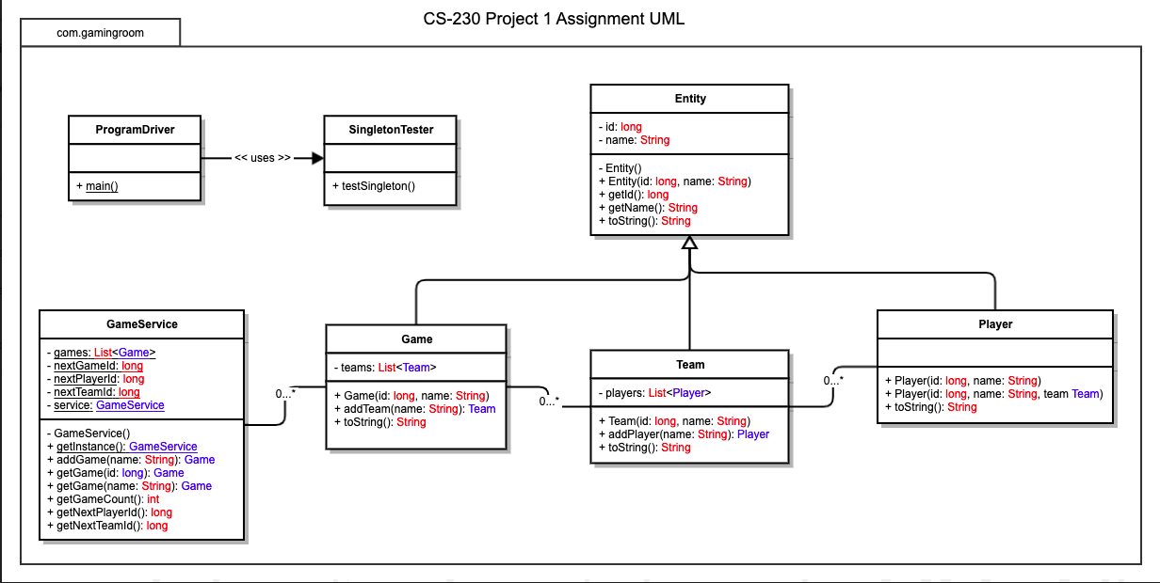

## Evaluation

Using your experience to evaluate the characteristics, advantages, and weaknesses of each operating platform (Linux, Mac, and Windows) as well as mobile devices, consider the requirements outlined below and articulate your findings for each. As you complete the table, keep in mind your client’s requirements and look at the situation holistically, as it all has to work together.

In each cell, remove the bracketed prompt and write your own paragraph response covering the indicated information.

| **Development Requirements** | **Mac** | **Linux** | **Windows** | **Mobile Devices** |
| --- | --- | --- | --- | --- |
| **Server Side** | Macs are better to use when it comes to front and back end development and have more usability than some other Operating Systems but come with a downside due to the price of most Macs. | Linux is a very stable OS that typically will not slow down over time. Linux is also less vulnerable when it comes to attacks since most attacks are made for Windows and Mac Operating Systems. The main disadvantage for Linux is the learning curve for those that are new to Linux. | Windows is an easy to use OS with an easy learning curve compared to Linux. Most older applications can still be used with newer versions of windows. Downsides include being pricey but not as bad as a Mac, as well as being more susceptible to attacks due to its wide use. | With mobile devices you have lower cost server side due to the lower needs and system requirements of a mobile device. At the same time, you have to deal with a limited selection of server side protections and limitations to the hardware. |
| **Client Side** | Mac is praised for its easy to learn keyboard shortcuts that are shared amongst all applications for the OS. This can be used to save time and help clients become more efficient. Mac is the 2nd most used OS meaning that many clients will already be used to using the Mac OS saving time with learning how to use it. | With Linux you have the same shortcuts as Mac that will spread across all applications. On top of that you have a wide range of security options that will keep your system safer than most Operating Systems. | Advantages that come with Windows is that the OS is widely used to most business. Meaning most client will already be familiar with the OS and help to save time. | Much like Windows, mobile devices and widely used and easier to understand than most Operating Systems. With mobile devices a client will be able to have the application with them at all times without any problem but will be somewhat limited to its usefulness and possibly taking away some features that would be available on the other Operating Systems. |
| **Development Tools** | With Mac you have languages such as Objective-C. Objective-C is basically C with added object-oriented programming. You also have the ability to get Homebrew which is an open-source package manager that makes it easier to install UNIX tools which is widely used due to how easy it is to work with. | Linux mainly uses the C programming language. This language is known for being extremely flexible meaning that you will use many different programing styles as you work. You still can use Java, Python, and C++. | The most relevant languages to use with Windows would be C++, C#, Javascript, and just like Linux C Tools that can be used to code would be applications such as Eclipse and VisualStudios. | The main programming language for mobile would be HTML5, it simplifies a lot of coding and accounts for different screen sizes as well as level of browser playing fields. Though you also have Java for Android app development and Swift for Apple app development. |

## Recommendations

Analyze the characteristics of and techniques specific to various systems architectures and make a recommendation to The Gaming Room. Specifically, address the following:

1. **Operating Platform**: The main Operating platform I would recommend for The Gaming Room would be to use the Windows OS. This is mainly because of its wide availability and popularity. This would be a good start for the game and would help to build towards expanding platforms.
2. **Operating Systems Architectures**: Basically the operating system of Windows is called Windows NT consist of two main parts, user mode and kernel mode. User mode is made up of various system-defined process. While kernel mode allows full access of hardware and system resources of the computer.
3. **Storage Management**: One form of storage that can be used by the Windows system is the OneDrive. This is a cloud file hosting service operated by Microsoft that comes with Microsoft Office. With the OneDrive the Gaming Room team would be able to save, access, and transfer files for Draw it or Lose it. Though there is a price barrier to use this service, the applications and usefulness of having a cloud based storage system will pay for itself with the amount of time that can be saved and how much space can be accessed for the storage.
4. **Memory Management**: On Windows there are multiple types of memory management that can be utilized for Draw it or Lose it. Windows can use memory allocation meaning it can set aside sections of memory for the program to store variables. It can also use fragmentation which will break down files and store than throughout a systems hard drive to help make more space for the system. You can also always check to see the amount of memory left on your system by using the Task Manager application.
5. **Distributed Systems and Networks**: With distributed systems and Networks you can connect potentially large numbers of people, hardware devices, and software together for things such as Draw it or Lose it for people to play together. Basically, this is a network that consist of computers connected through a distribution middleware that helps to share resources among those computers. Some issues that arise with using a system like this is performance which can start to fall when more computers are added to the equation which can affect the speed as well. On top of that the ability to manage this system may become a problem to those who aren’t ready to handle a system that could grow quickly with time.
6. **Security**: In terms of security Windows comes with its own anti-virus software called Microsoft defender, but being that it’s a free software you wont have as much security coming from a software you would have to pay for. One decent all-around security software would be Norton 360. This software works with most OS’s such as windows, android, and mac. This software comes with Malware and Virus protection as well as a VPN.